The correct display of navigation lights is fundamental in avoiding collisions. You cannot be exhonorated of blame if you were not showing the correct lights at the time of the collision.

The rules for displaying navigation lights as they apply to Namadgi-3 are:

* You must switch on the appropriate lights between sunset and sunrise and in very poor visibility.
* When under sail (diesel stopped or forward gear not engaged), you have a choice of navigation lights. You can either switch on the combined red white and green lantern or tri-light, or the port and starboard sidelights and the white sternlight, but not both sets together. No other lights may be switched on. The advantages of the combined tri-light are that it can be seen more easily and uses less electrical power. The tri-light is less effective in busy places like Sydney harbour.

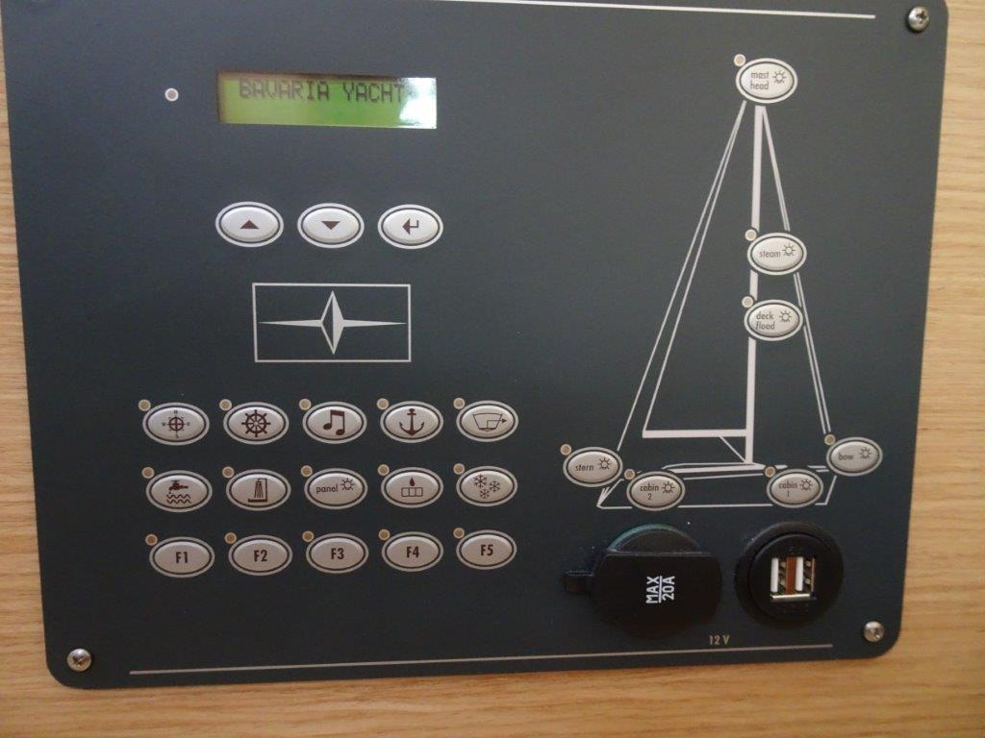

To turn the navigation lights on:

* Tri-light = F1

Or,

* Port & Starboard Side navigation lights = Bow

And,

* Stern light = Stern
* When under power (propelling with the diesel, and whether or not sails are set), there is no choice. You must switch on the sidelights, the white sternlight, and the white Steaming light on the front of the mast. No other lights may be switched on. Turn of the tri-light.

To turn these lights on:

* Switch on the Side and Stern navigation lights as above
* Steaming light = Steam
* When at anchor switch on the all-round white anchor light at the top of the mast. No other lights may be switched on. Some jurisdictions in Queensland now enforce using the anchor light at a mooring.

To turn this light on:

* Anchor light = Mast head